Project Design Phase
Solution Architecture

Date | 15 February 2025
Team ID | LTVIP2026TMIDS86089
Project Name | Order On The Go: Your On-Demand Food Ordering Solution
Maximum Marks | 4 Marks

Solution Architecture – SB Foods

Goals of the Architecture
- Provide the best technical solution to address late-night food ordering and restaurant management challenges.
- Clearly describe the structure, behavior, and flow of the system to stakeholders.
- Define features, development phases, and solution requirements.
- Deliver specifications for deployment, scalability, and performance.
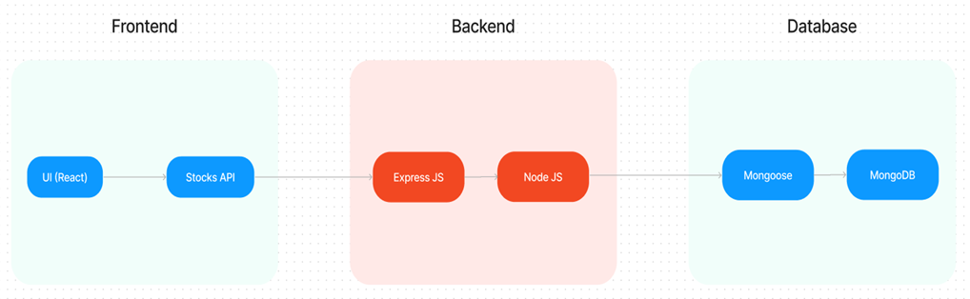

Architecture Description
The SB Foods solution follows a 3-tier MERN architecture with integrations for payments, notifications, and restaurant dashboards.
- Frontend (Client Layer)
  - Built with React.js, HTML, CSS, JavaScript.
  - Provides user interface components: registration, login, product catalog, cart, order placement, profile, and admin dashboard.
  - Responsive design for both web and mobile.
- Backend (Application Layer)
  - Developed using Node.js + Express.js.
  - Exposes RESTful APIs for user authentication, product browsing, cart operations, order placement, and admin management.
  - Integrates with external APIs (Google Maps for delivery, Firebase for notifications, Stripe/Razor pay for payments).
- Database Layer
  - MongoDB Atlas (NoSQL) stores collections for Users, Restaurants, Products, Carts, and Orders.
  - Ensures scalability and high availability.
  - Supports indexing and optimized queries for performance.
- External Services
  - Payment Gateway: Stripe/Razor pay for secure transactions.
  - Notification Service: Firebase Cloud Messaging for order updates.
  - Location Service: Google Maps API for delivery tracking.
  - File Storage: AWS S3 for product images and user profile pictures.
- Infrastructure
  - Deployment on AWS EC2 / Kubernetes for scalability and resilience.
  - Load balancers ensure high availability.
  - CDN (Cloudflare) improves performance and response times.

